**FINAL REPORT**



**PROJECT**: RUBIK’S CUBE SOLVER

**Submitted to**: - SAGAR PANDE

|  |  |  |
| --- | --- | --- |
| Roll no | Registration no | Name |
| 31 | 11801780 | AYUSH DWIVEDI |
| 62 | 11801809 | SASWATA BHUNIA |

**1.ABSTRACT:**

This project is all about the system to solve a 3X3 Rubik’s cube using colour detection for scanning all 6 faces of the cube and further depicting the sequential steps to solve the cube. The algorithm used is known as kociemba’s 2 phase algorithm. Using a recursive tree, higher order cubes of dimensions 4X4,5X5…. Etc have been approached to be formulated but that requires high knowledge and precision of underlying moves. Conventionally, a 3X3 Rubik’s cube has the following total no of possibilities:

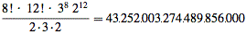

So to compute all permutations is not an efficient task, hence some brain storming and associated algorithm have been designed and put to practice so effectively solve. Till date, God’s algorithm provides a superhuman: maximum 20 moves solution to any 3X3 Rubik’s cube. Hence our project has aimed to design a system to solve a 3X3 Rubik’s cube in a more interactive manner.

**2.INTRODUCTION:**

**2.1 Aim:** This project is aimed at solving a 3X3 Rubik’s cube with any given initial state.

**2.2 Motivation:** Rubik’s cube always seems an interesting object which involves a lot of mind-sport, thus like acing in any other sport, solving Rubik’s cube from any initial state to final state is always highly motivating.

**2.3 Objectives:** To take input from user as the given initial state and solve the Rubik’s cube depicting the step for every intermediate state.

**2.4 Scope:** This project can further be extended towards solving a Rubik’s cube with minimum number of intermediate steps for better efficiency.

**3.Related Work (Existing Work Analysis):**

Already a lot of work has been done, historically in the development of efficient algorithms in solving a 3X3 Rubik’s cube. The most efficient algorithm we have achieved so far is known as the Kociemba’s 2 phase algorithm, and the God’s number: which is the smallest number of moves required to solve a Rubik’s cube from any given unsolved initial state, has been achieved = 20 using Kociemba’s 2 phase algorithm. Subsequent binary recursive trees have been applied to solve Rubik’s cube of a higher order but with lesser efficiency.

**4.IMPLEMENTATION:**

* Firstly, all the sides of the cube are scanned using opencv with the help of the front camera.
* The algorithm (Kociemba 2 phase) then works detecting all the sides and formulating the moves.
* The moves are named as follows as in the official scenario:
  + F (Front): the side currently facing the solver
  + B (Back): the side opposite the front
  + U (Up): the side above or on top of the front side
  + D (Down): the side opposite the top, underneath the Cube
  + L (Left): the side directly to the left of the front
  + R (Right): the side directly to the right of the front
  + ƒ (Front two layers): the side facing the solver and the corresponding middle layer
  + b (Back two layers): the side opposite the front and the corresponding middle layer
  + u (Up two layers): the top side and the corresponding middle layer
  + d (Down two layers): the bottom layer and the corresponding middle layer
  + l (Left two layers): the side to the left of the front and the corresponding middle layer
  + r (Right two layers): the side to the right of the front and the corresponding middle layer
  + x (rotate): rotate the entire Cube on R
  + y (rotate): rotate the entire Cube on U
  + z (rotate): rotate the entire Cube on F
  + When a [prime symbol](https://en.wikipedia.org/wiki/Prime_(symbol)) ( ′ ) follows a letter, it denotes an anticlockwise face turn; while a letter without a prime symbol denotes a clockwise turn. These directions are as one is looking at the specified face. A letter followed by a 2 (occasionally a superscript 2) denotes two turns, or a 180-degree turn. R is right side clockwise, but R′ is right side anticlockwise. The letters x, y, and z are used to indicate that the entire Cube should be turned about one of its axes, corresponding to R, U, and F turns respectively. When x, y, or z are primed, it is an indication that the cube must be rotated in the opposite direction. When they are squared, the cube must be rotated 180 degrees.
* Finally, the required sequential path is described to solve the Rubik’s cube with the above notations.

**5.CODE SNIPPET:**

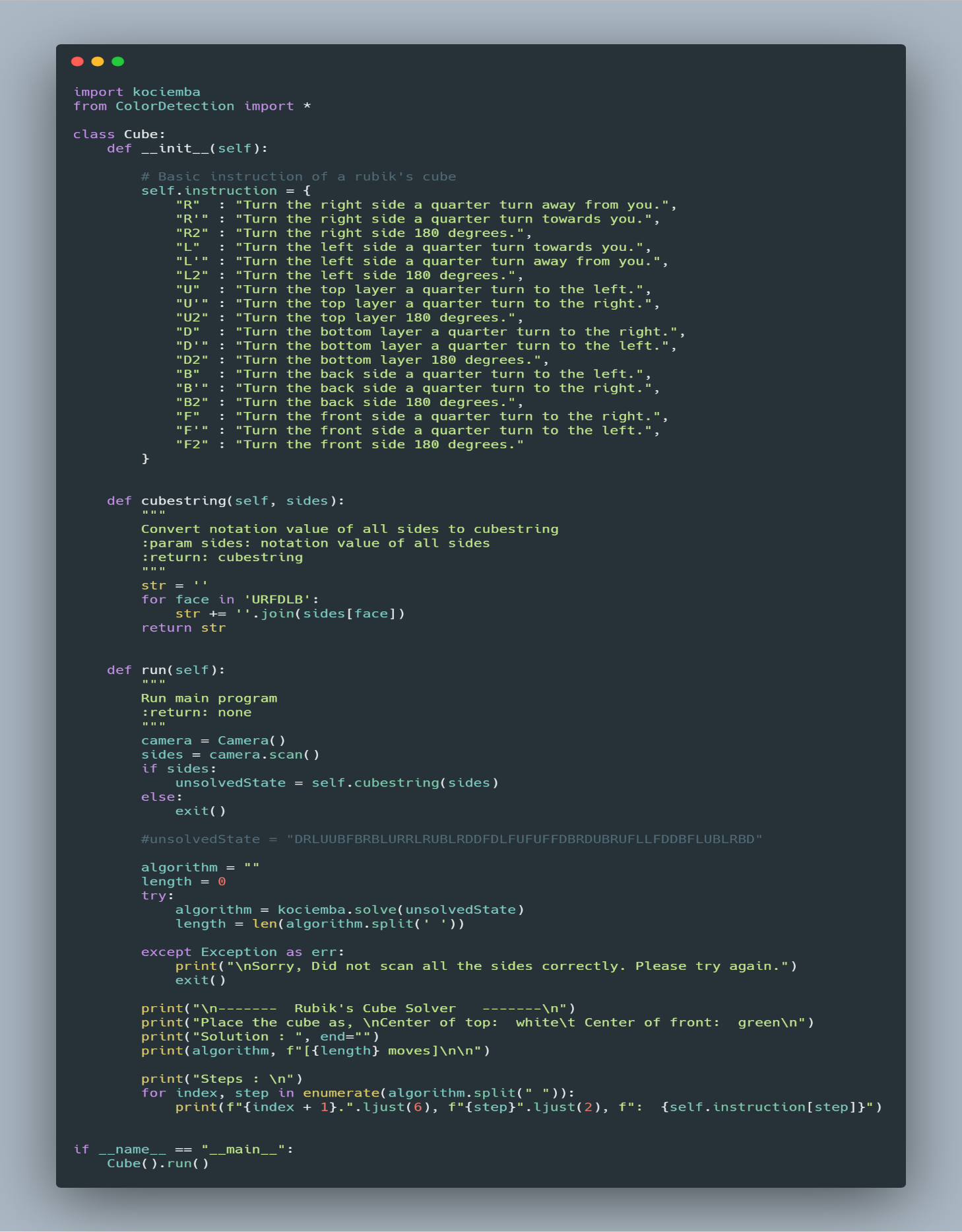

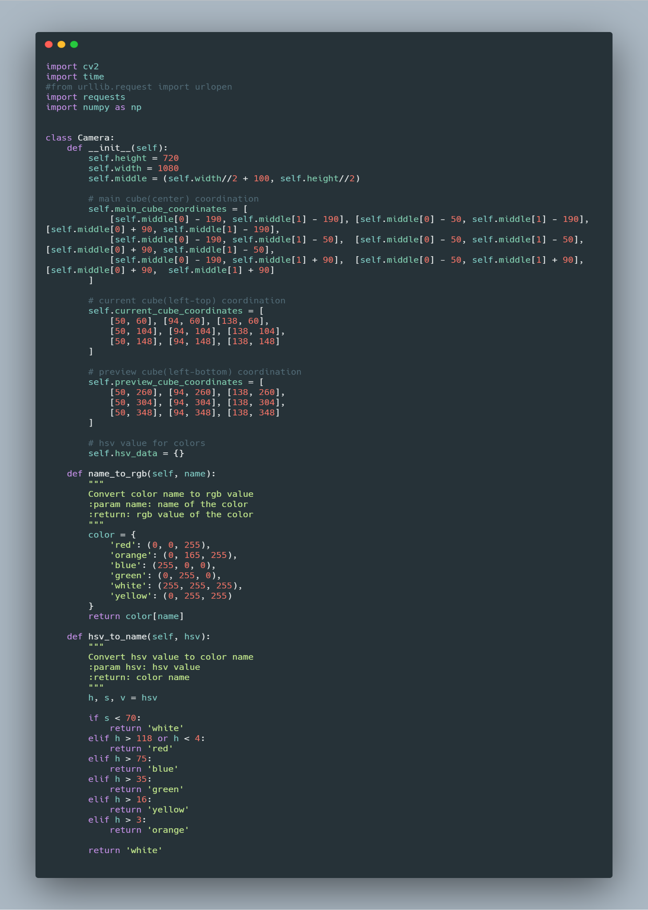

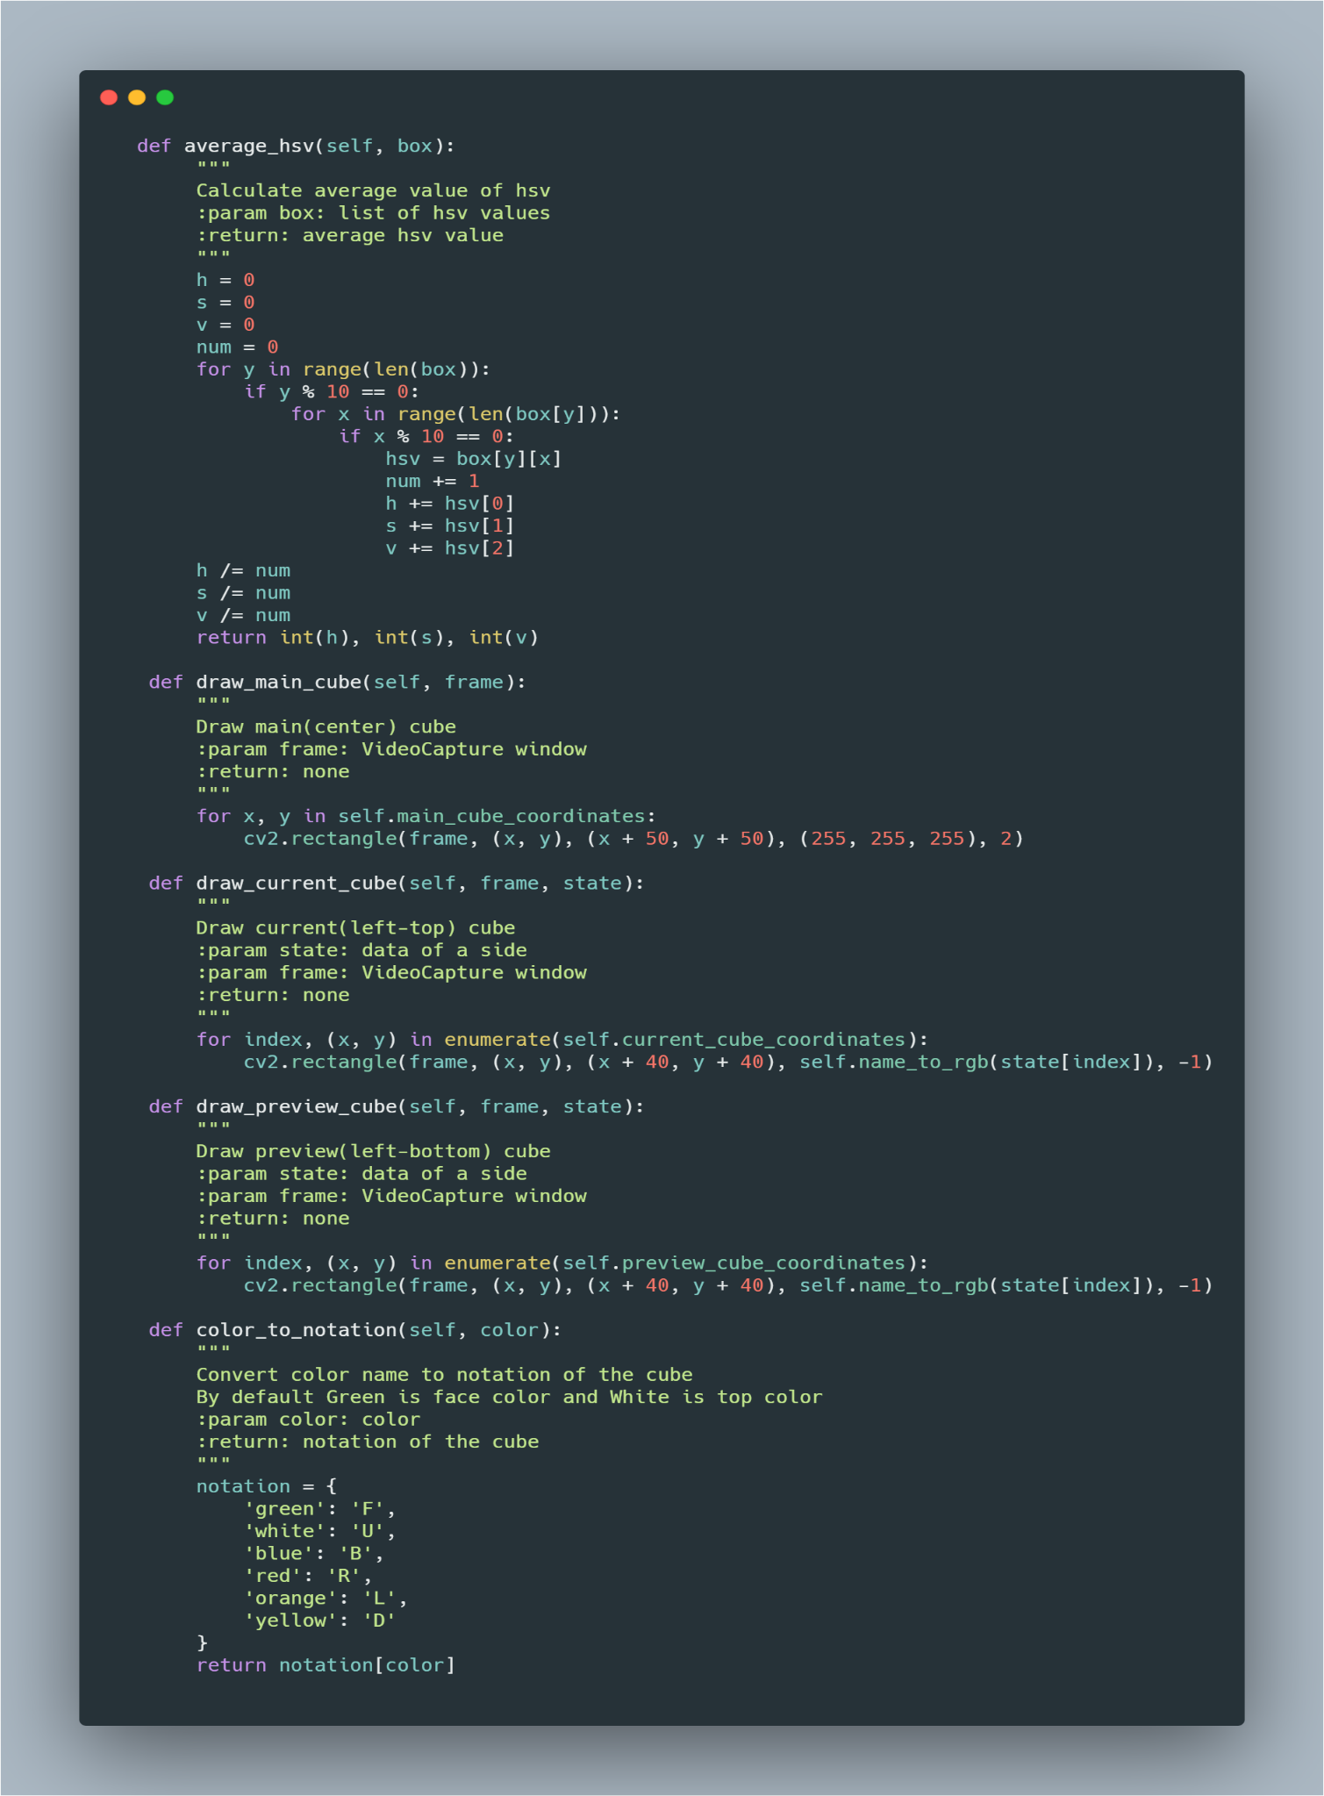

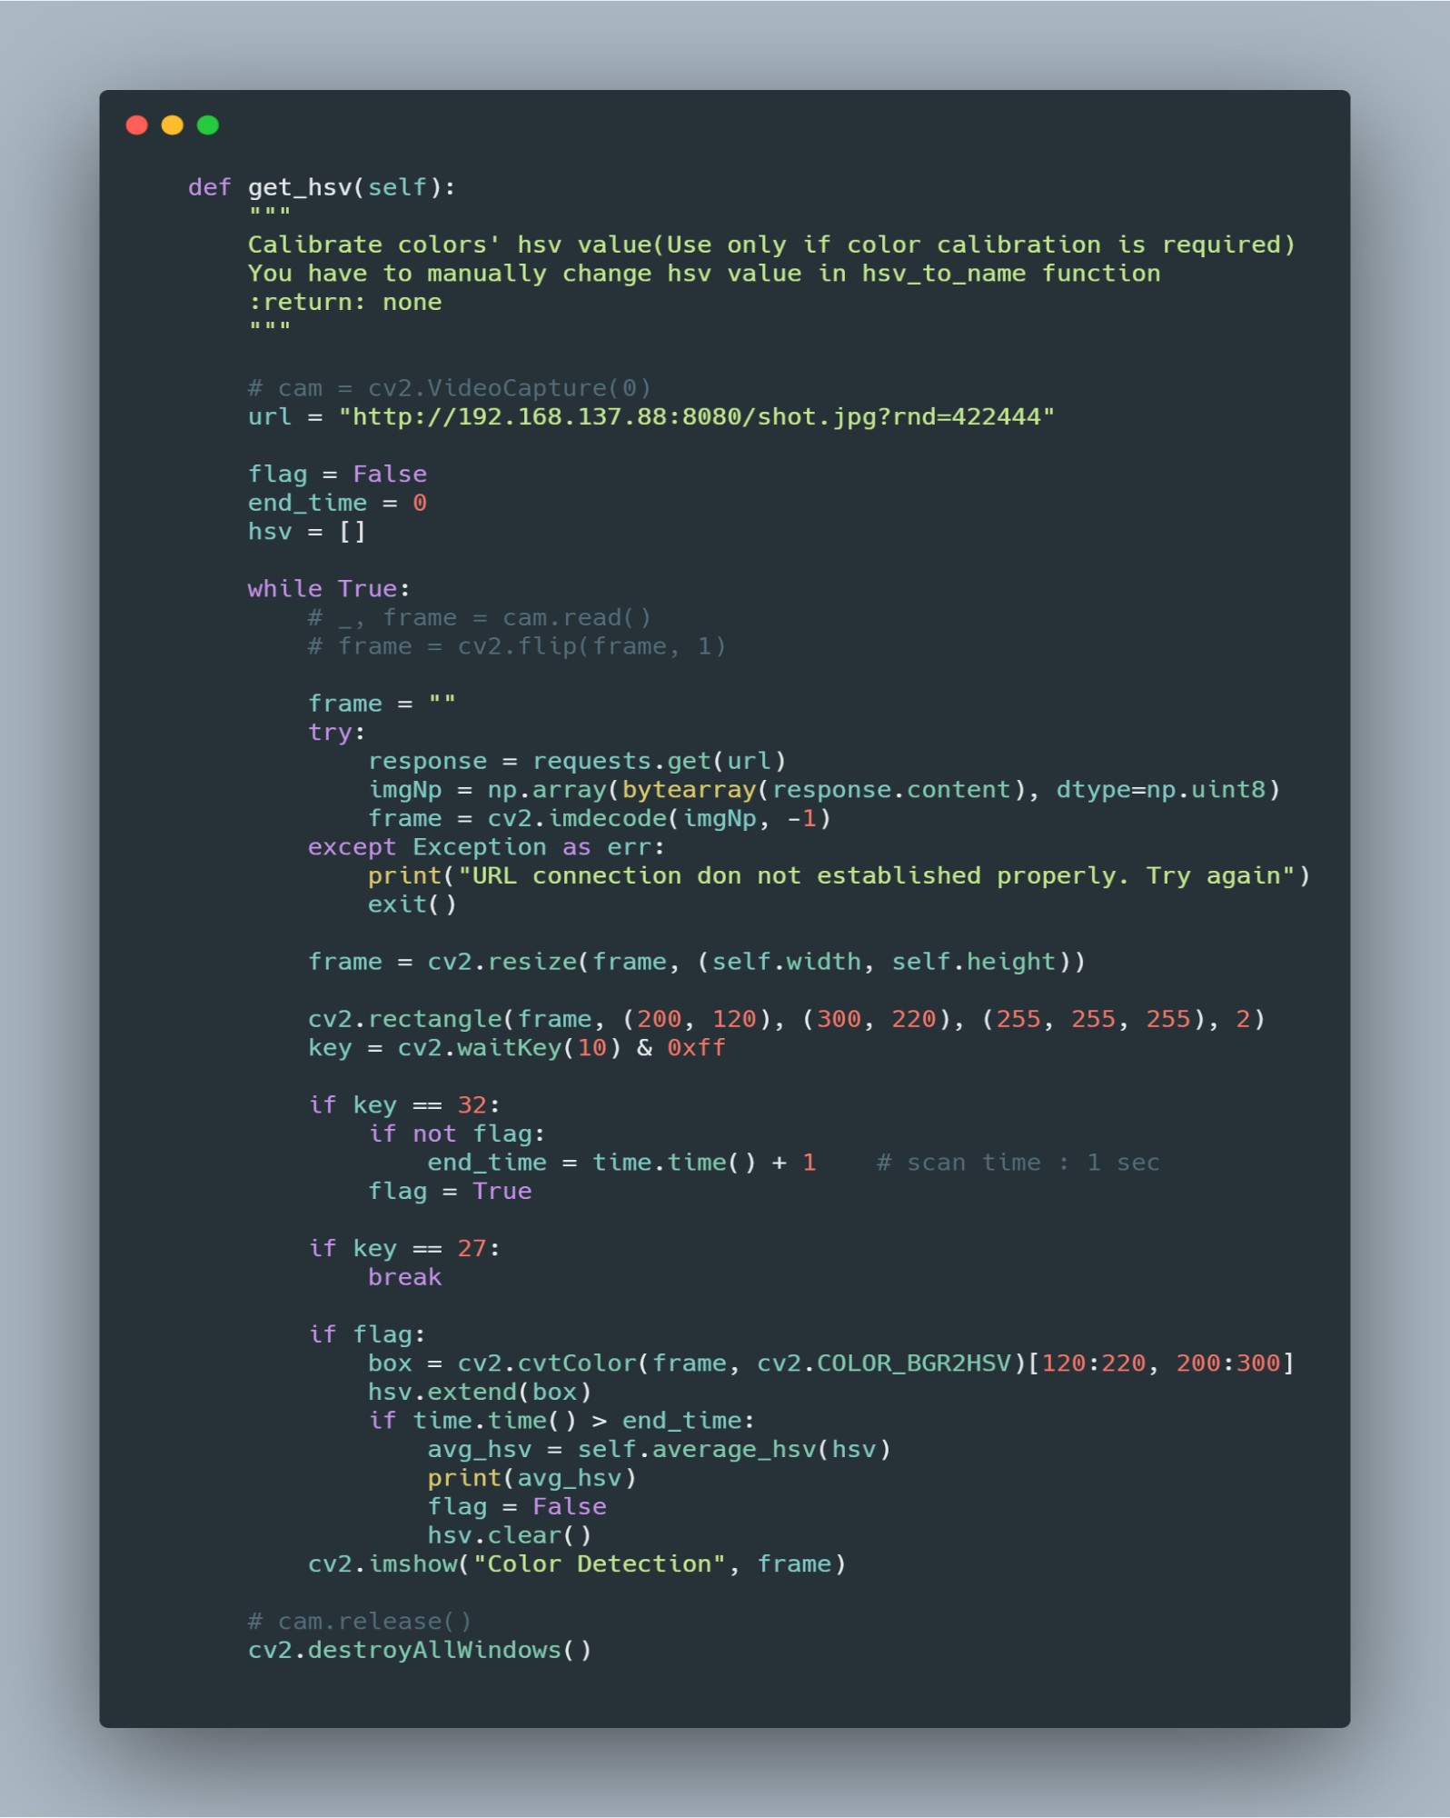

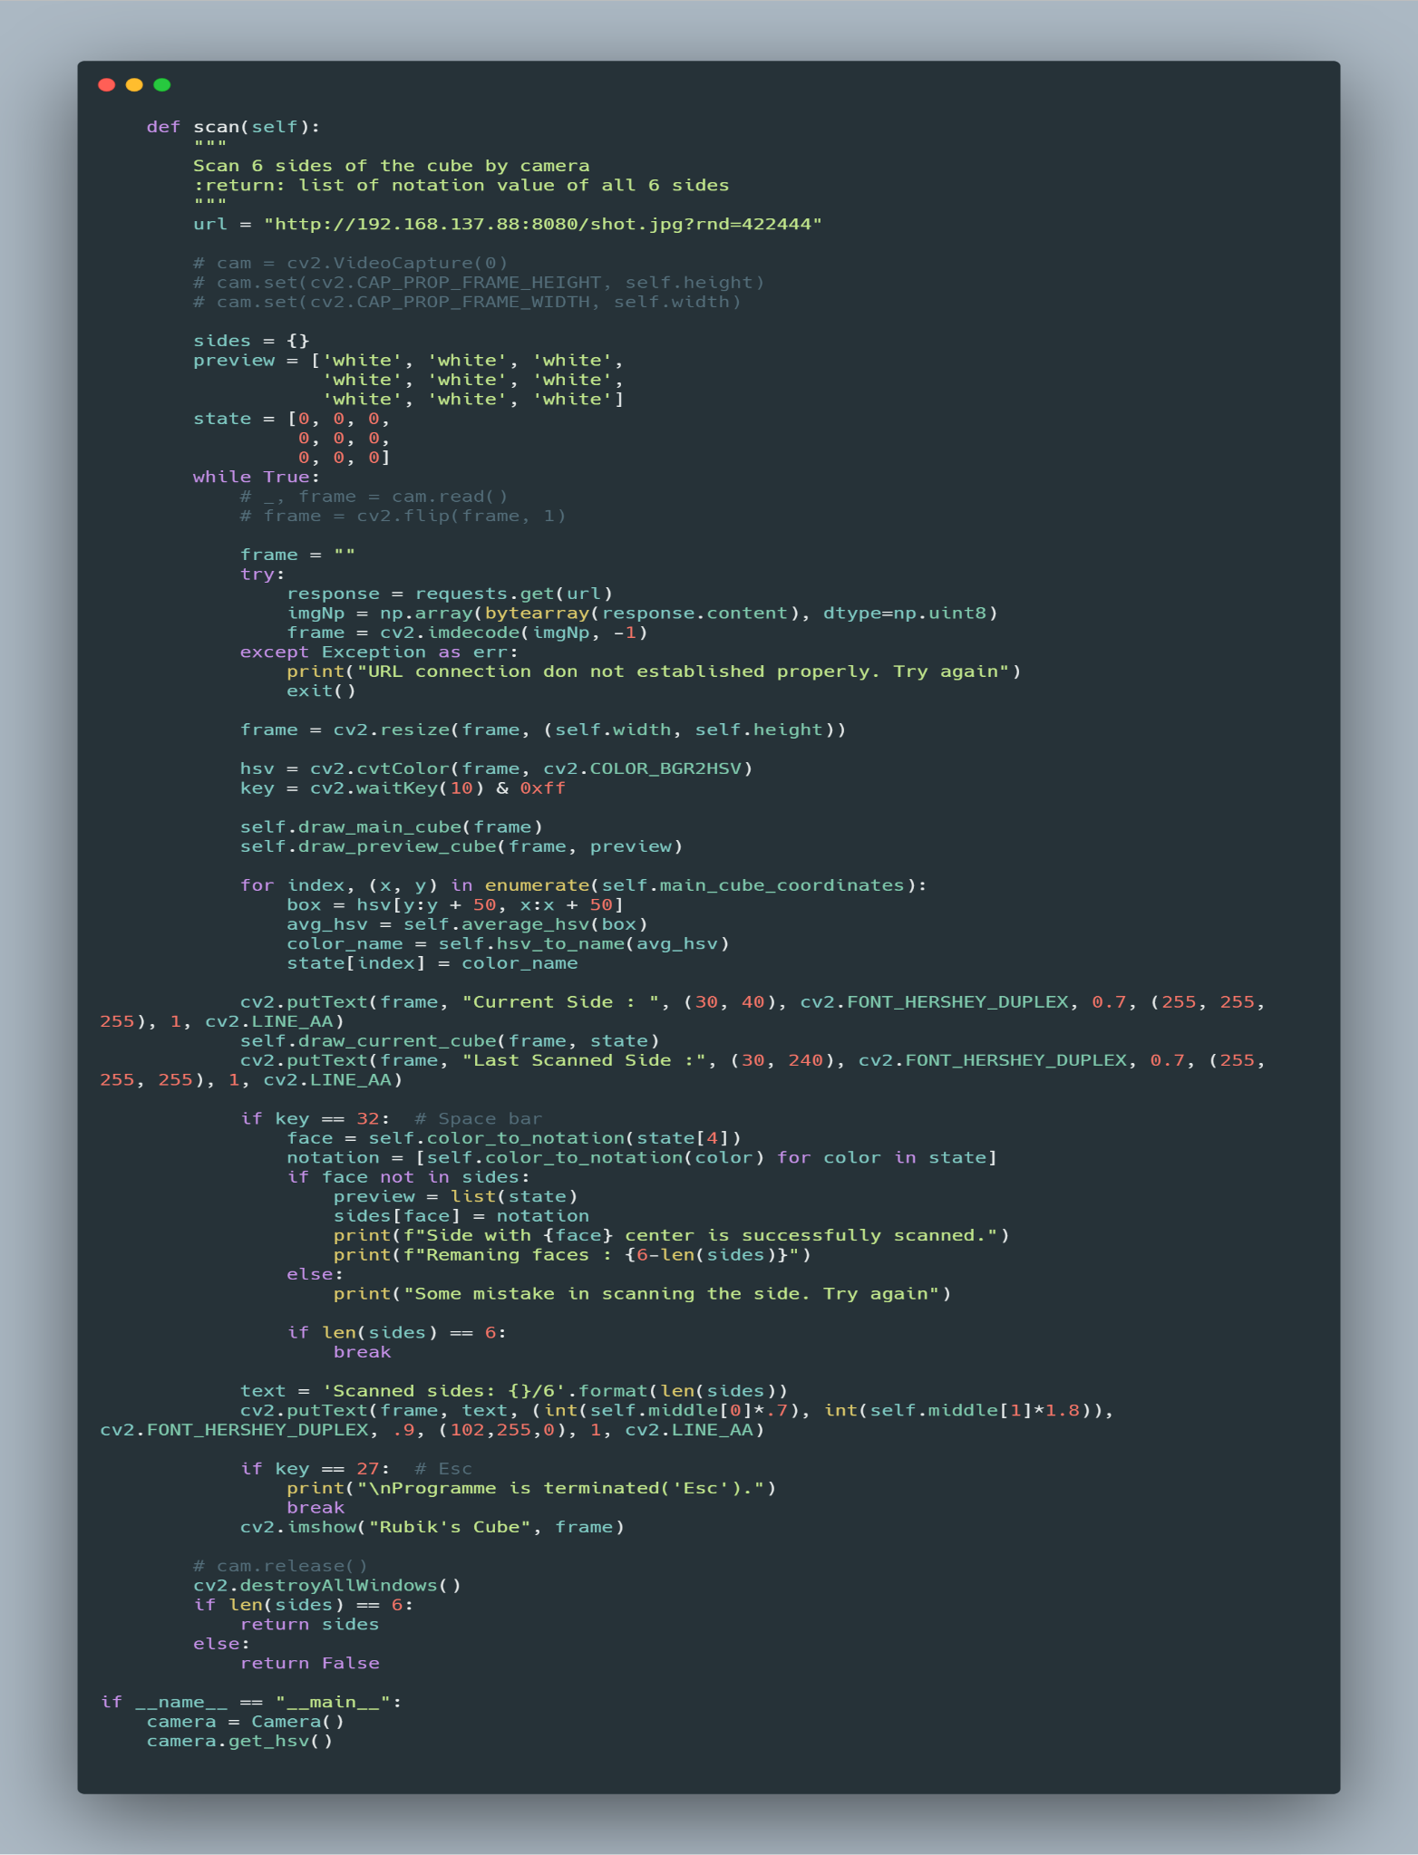

**7. INPUT:**

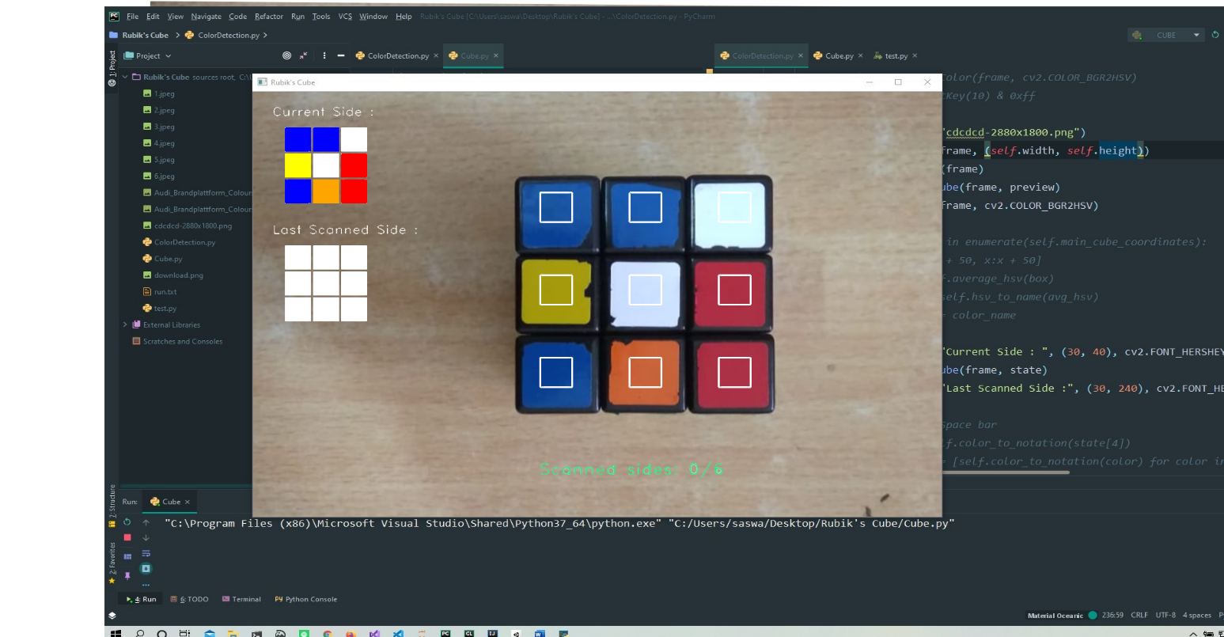

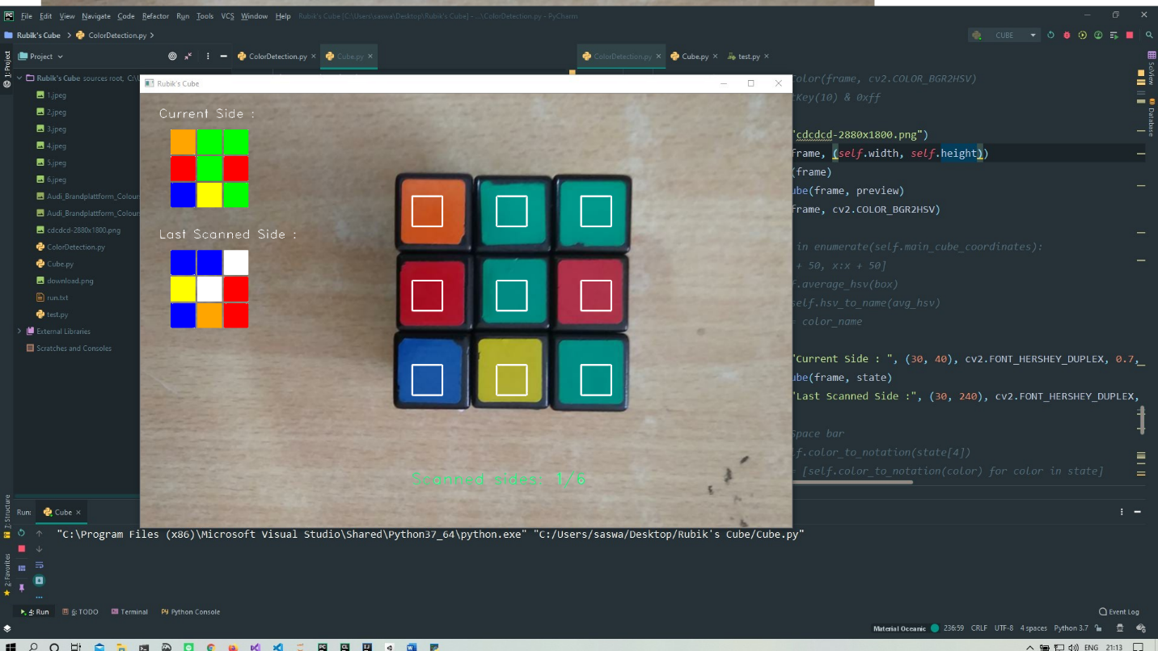

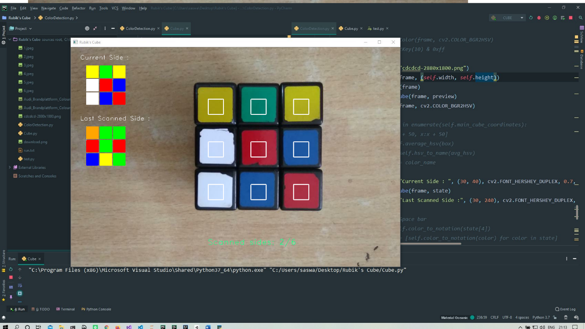

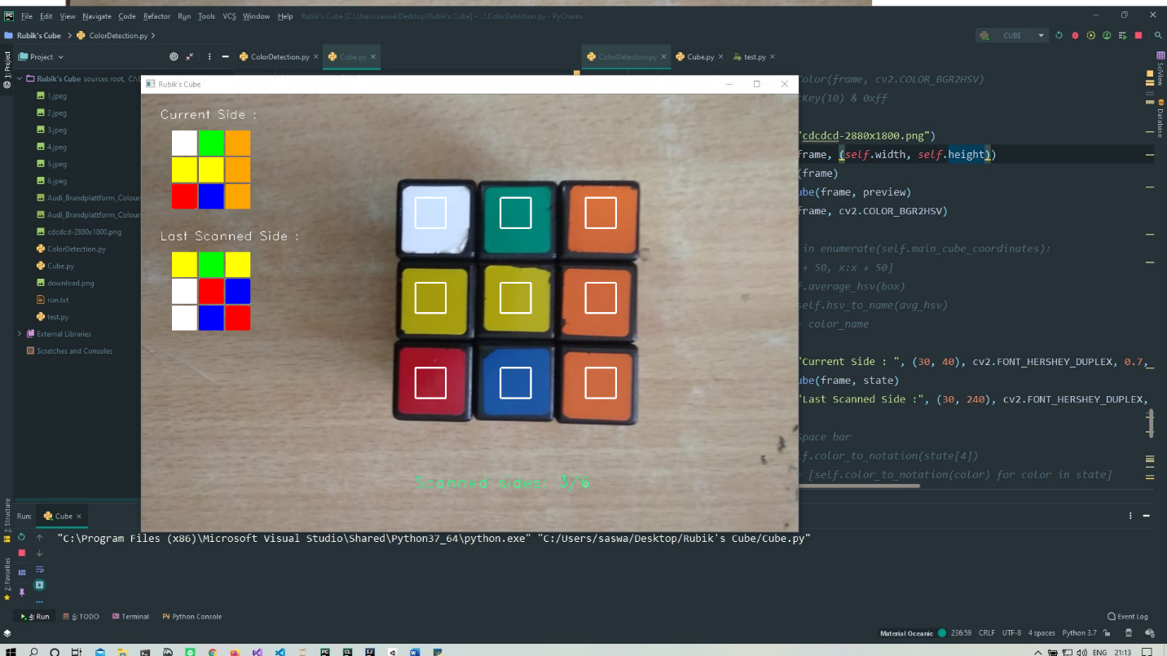

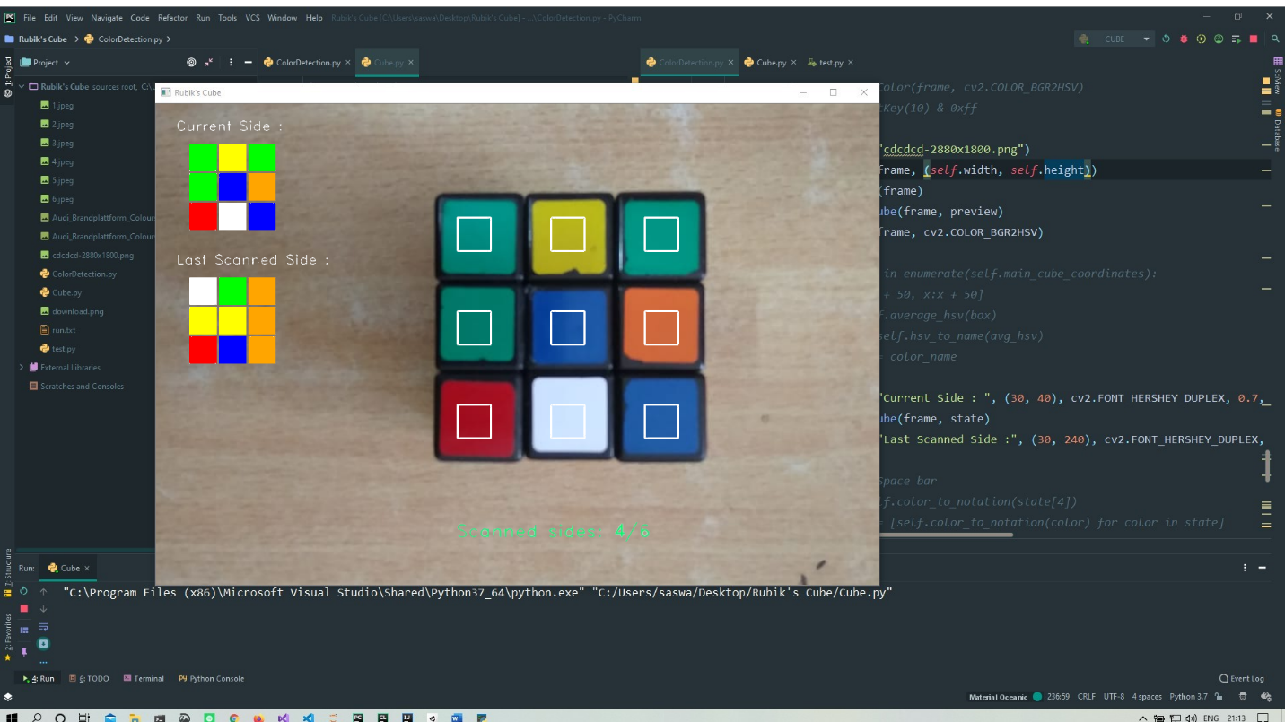

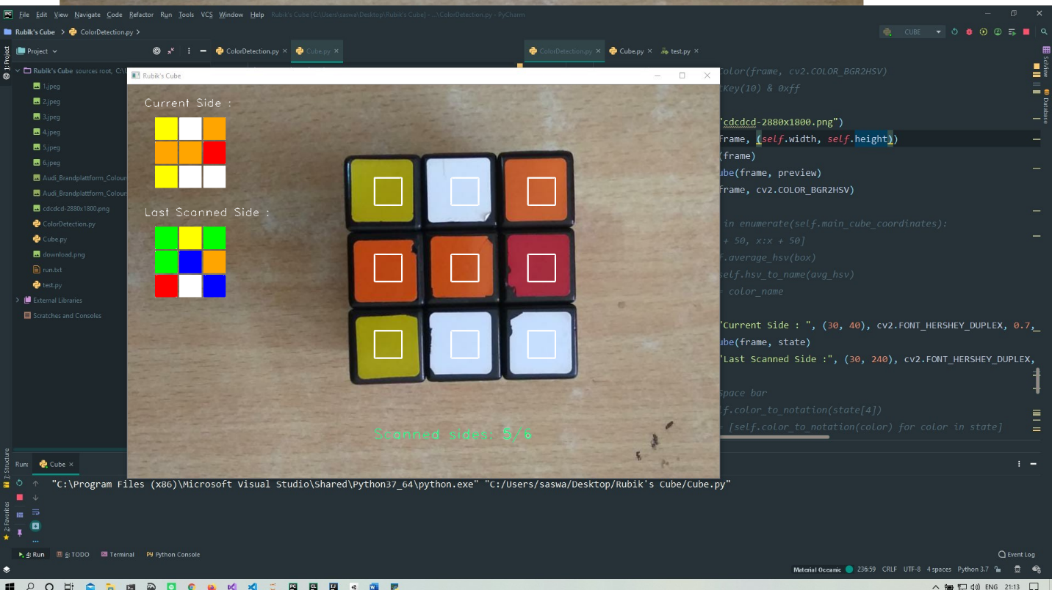

**8. OUTPUT:**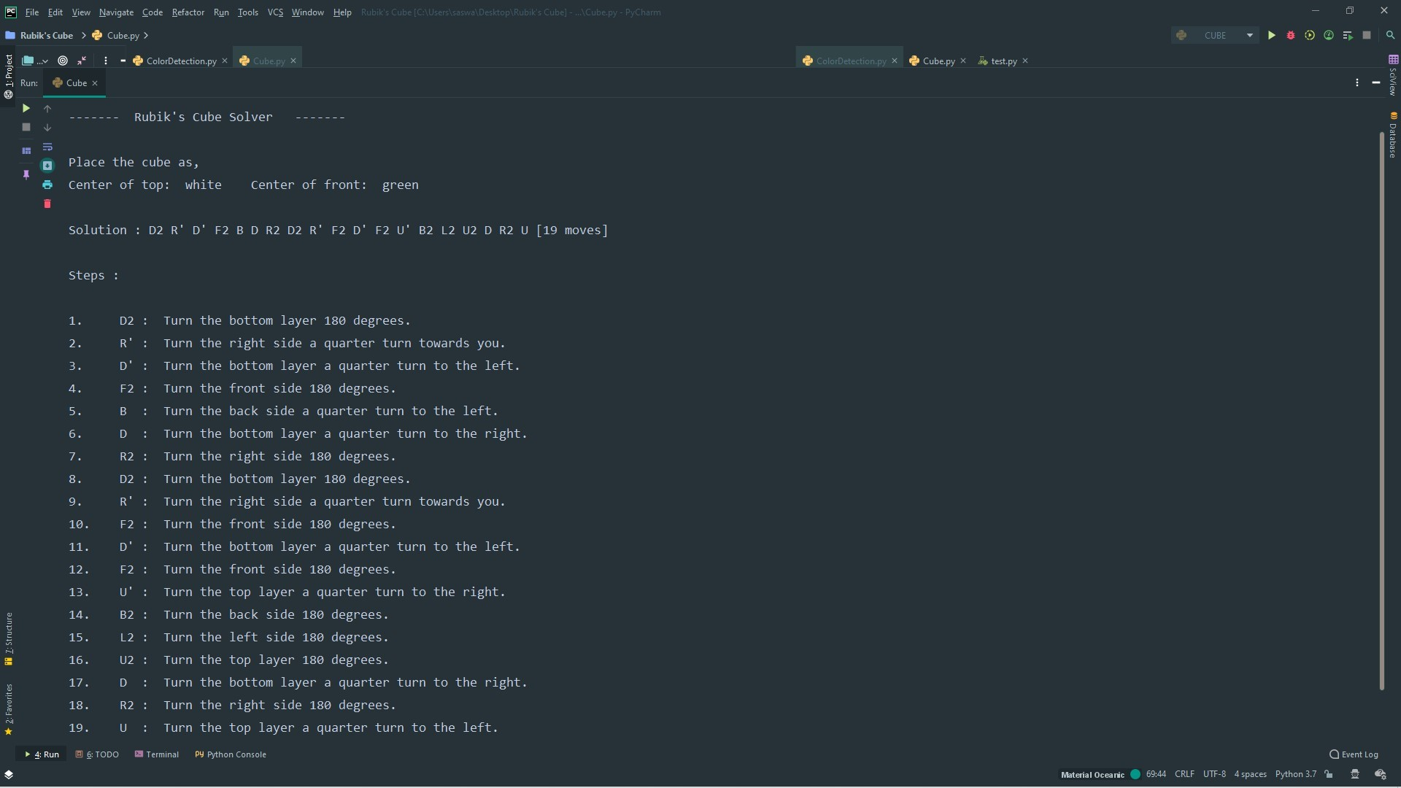

**9. TEAM RESPONSIBILITIES:**

This project has been done in a shared space where both the team members have contributed equally in completion of the project. Specifically:

The algorithmic part for solving a Rubik’s cube has been handled by group member **AYUSH DWIVEDI.**

The interface part for solving a Rubik’s cube has been handled group member **SASWATA BHUNIA.**

**10. LIBRARY USED:**

Numpy: Used to define array

Math: Used to compute mathematical operations

Opencv (cv2): To take pictorial input of Rubik’s cube using color detection.

Matplotlib: Used to store previous data.

Kociemba: To solve the cube. (main algorithm)

Time: To use the time function to run the program for a certain amount of time

Requests: To perform URL requests (use for access mobile camera)

**11. REFERENCES:**

[**https://en.wikipedia.org/wiki/Rubik's_Cube**](https://en.wikipedia.org/wiki/Rubik's_Cube)

[**http://kociemba.org/math/imptwophase.htm**](http://kociemba.org/math/imptwophase.htm)

[**https://en.wikipedia.org/wiki/Optimal_solutions_for_Rubik%27s_Cube**](https://en.wikipedia.org/wiki/Optimal_solutions_for_Rubik%27s_Cube)

[**https://en.wikipedia.org/wiki/God%27s_algorithm**](https://en.wikipedia.org/wiki/God%27s_algorithm)

[**https://www.rubiks.com/en-us/how-to-solve-rubiks-cube**](https://www.rubiks.com/en-us/how-to-solve-rubiks-cube)

**12. GITHUB LINK:**

<https://github.com/akdrishu/AI>

<https://github.com/Saswata99/Rubik-s-Cube>